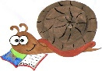
Lyng Primary School Knowledge Organiser

History Topic: | Great and Ghastly Events | Year 1  The Great Fire of London | Autumn 2
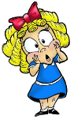
What Step On and Goldilocks words will I use?
Spelling | Definition
bakery | A place where bread or cakes are made and sold
London | The capital city of England and the United Kingdom
River Thames | Many people got a boat on the River Thames to escape the fire
diary | A personal record of life’s events
eye-witness | A person who has seen something and can give a description of it
embers | Small pieces of glowing coal or wood in a dying fire used to pull down houses
fire-break | When buildings are destroyed to make a gap so the fire can’t spread
flammable | When something burns easily
St Paul’s Cathedral | A Christian building razed to the ground in the fire and rebuilt using designs by Sir Christopher Wren.

Background information for parents and teachers

The Fire of London started on 2nd September 1666 and lasted for 5 days. The weather in London was hot and hadn’t rained for months. Houses in London were mainly built from wood which is flammable, especially when it is very dry. The houses were also very close together, so fire could easily spread.

When? (Timeline of key events)
Hook
Children make houses and burn them down to create the Great Fire of London.

TRIP/VISITOR
Moon Landing
Visiting the space centre
"So down I went, with my heart full of trouble...."
- Samuel Pepys
Great Quotes

Our Storytelling Approach to enhance engagement

People:  Mayor of London | Place:  London | Problem:  All of the houses are burning down and people are becoming angry and frustrated.
Key People
Agreed Outcome
Use Samuel Pepys diary to write your own diary entry.

Thomas Farriner
An ember from one of Thomas’ bakery ovens ignited some nearby firewood. The fire quickly spread around the room and to nearby buildings.
Samuel Pepys
One of the ways we know about the fire is because people wrote about it in their own personal diary.
King Charles II
Charles II was the King of England in 1666. After the fire, he made a decree that houses must be built further apart and built from stone not timber.

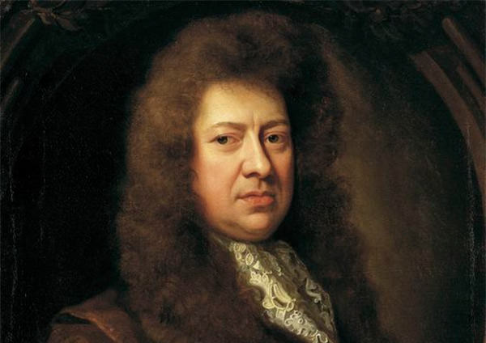
- Observe or handle evidence to ask questions and find answers to questions about the past.
- Ask questions such as: What was it like for people? What happened? How long ago?
- Use artefacts, pictures, stories, online sources and databases to find out about the past.
- Label time lines with words or phrases such as: past, present, older and newer.
- Use dates where appropriate.
- Use words and phrases such as: a long time ago, recently, when my parents/carers were children, years, decades and centuries to describe the passing of time.
Key skills – Taken from Milestone 1 – Sequence of Learning

#

Lyng Primary School Knowledge Quiz

History Topic: Great and Ghastly Events | Great Fire of London | Year 1 | Spring 1
5. What material were the houses made from? | S | E
Metal
Bricks
Wood

- Where did the fire start? | S | E
- A hospital
- A school
- A bakery
Our Great Fire of London Quick Quiz
- The fire started in the year… | S | E
1666
1823
2020
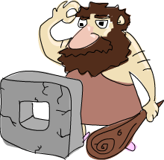
- Who started the fire? | S | E
Miss Hartshorne
Thomas Farriner
Catholic people

- How many days did the fire last? | S | E
5
4
2

